# Install UiPath Test Manager for Jira

1. Open your Jira instance in your browser.
2. Log in as an administrator.
3. Click **Manage Apps** from the administration menu.
4. Under **Find new Apps** search for UiPath.
5. Select **UiPath Test Manager for Jira**.
6. Click **Install**.  
   The latest version of UiPath Test Manager for Jira is installed.







# Configure Jira connection

All the objects that you create in Test Manager will have the identity of the Jira user used for this connection. To configure a Jira connection in Test Manager, follows these steps:

1. Log in to Test Manager as an administrator.
2. Open your project.
3. Navigate to **Project Settings** > **Integration**.
4. Click **New Connection** and select either **Jira Server**.
5. Configure the following connection settings:
   * **Name**: Enter a name for your Jira connection.
   * **Description** (Optional): Add a description for reference.
   * **Server URL**: Add the Jira server URL. This is the URL of the server that exposes the Jira REST API. It is usually identical to the URL you navigate to when using Jira through your browser. For example: https://company-name.atlassian.net.
   * **Web URL** (Optional: Enter the URL of the Jira REST API in case the Jira REST API is not hosted under the same URL such as the web UI.
   * **User**: The username you use to authenticate to the Jira API.
   * **Password**: The password you use to authenticate to the Jira API.
   * **Defect Type**: Specify the Jira object-type to be used for defects. Usually, that will be a bug. To disable defect integration for this connection, select **None**.
   * **Project Key**: Enter the project key from Jira which refers to the project you want to integrate. (This key should match the key you have given while creating JIRA Project)
6. Click **Save**.
7. Click the connection to expand the panel and copy the **API Key** for later use.

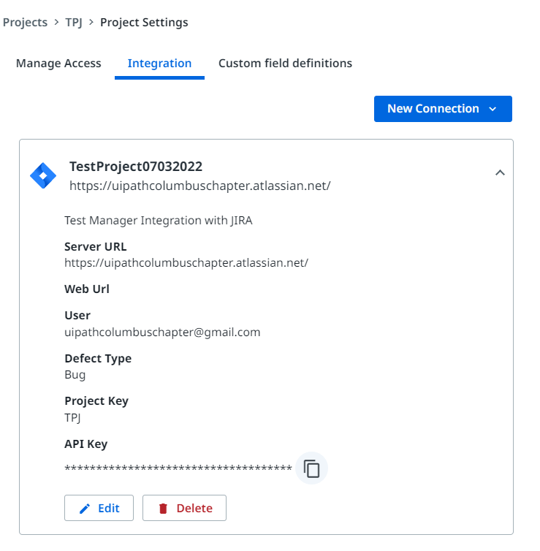

# Configure Jira project

1. Open Jira and navigate to the project you want to integrate with Test Manager.
2. Switch to the project settings.
3. Scroll down and select **UiPath Test Manager** to open the Test Manager configuration page.

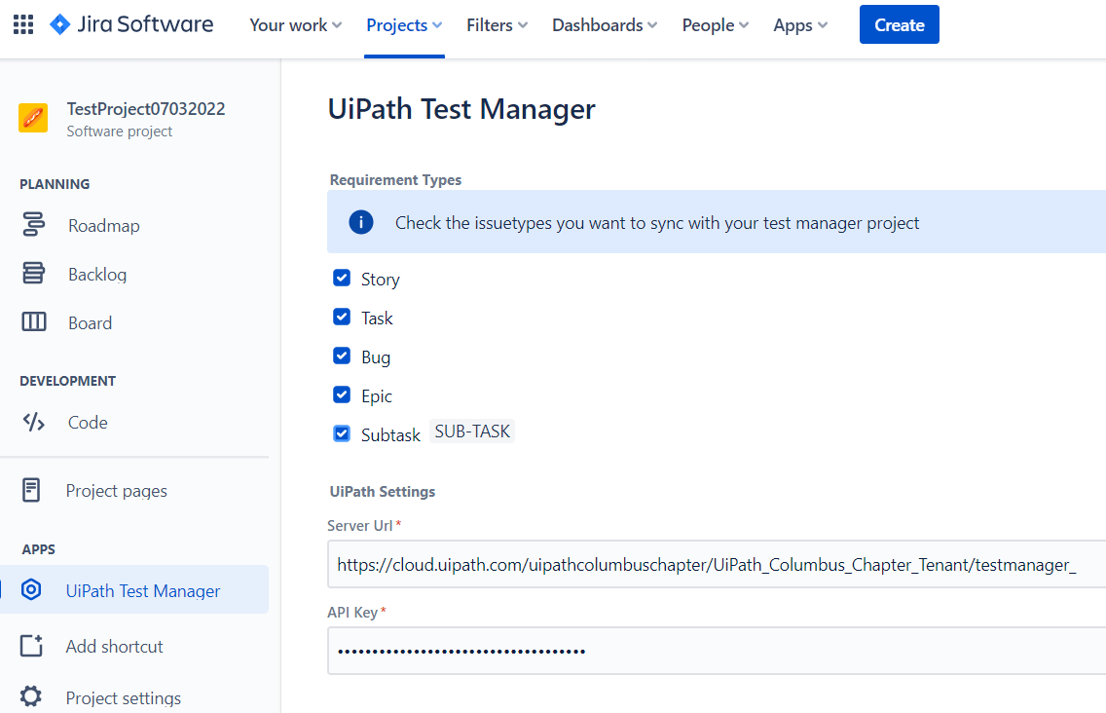

1. Select all Jira issue types that you want to be synchronized as requirements to Test Manager.
2. Enter the **Server URL** from Test Manager (e.g., https:/.uipath.com/companyName/tenantName/testmanager_/).
3. Paste the **API Key** you copied at step 7 from the previous procedure.
4. Click **Save**.